**Experiment No. - 2**

**Name-** Bhavesh Kewalramani

**Roll No.-** A-25

**Section-**  A

**Semester-** 6th

**Shift-** 1st

**Aim:**

To create Use-Case diagram to depict the user’s view of the IRCTC Reservation System.

**Theory:**

The Unified Modeling Language (UML), a use case diagram can summarize the details of your system's users (also known as actors) and their interactions with the system. To build one, you'll use a set of specialized symbols and connectors. An effective use case diagram can help your team discuss and represent:

* Scenarios in which your system or application interacts with people, organizations, or external systems
* Goals that your system or application helps those entities (known as actors) achieve
* The scope of your system

**When to apply use case diagrams**

A use case diagram doesn't go into a lot of detail—for example, don't expect it to model the order in which steps are performed. Instead, a proper use case diagram depicts a high-level overview of the relationship between use cases, actors, and systems. Experts recommend that use case diagrams be used to supplement a more descriptive textual use case.

UML is the modeling toolkit that you can use to build your diagrams. Use cases are represented with a labeled oval shape. Stick figures represent actors in the process, and the actor's participation in the system is modeled with a line between the actor and use case. To depict the system boundary, draw a box around the use case itself.

UML use case diagrams are ideal for:

* Representing the goals of system-user interactions
* Defining and organizing functional requirements in a system
* Specifying the context and requirements of a system
* Modeling the basic flow of events in a use case

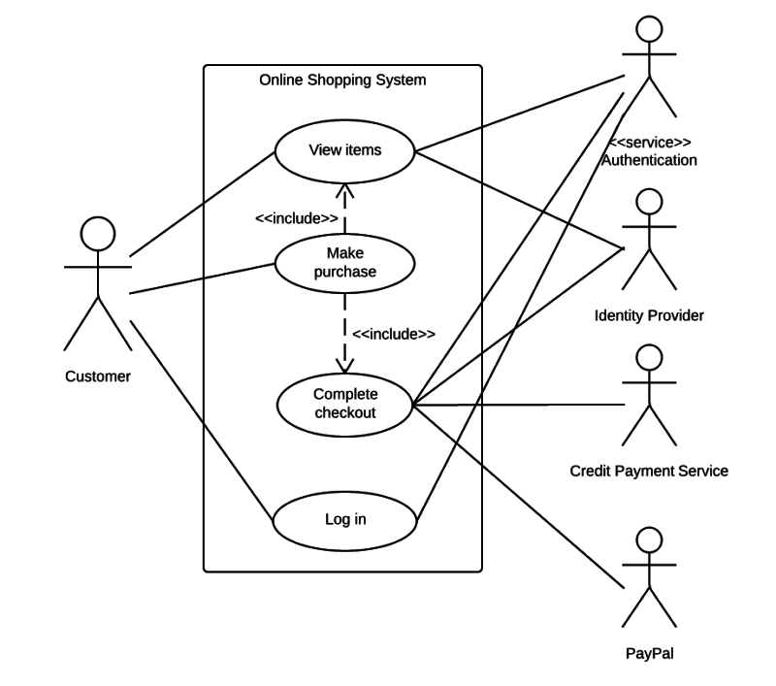

## Use case diagram components

To answer the question, "What is a use case diagram?" you need to first understand its building blocks. Common components include:

* **Actors:** The users that interact with a system. An actor can be a person, an organization, or an outside system that interacts with your application or system. They must be external objects that produce or consume data.
* **System:** A specific sequence of actions and interactions between actors and the system. A system may also be referred to as a scenario.
* **Goals:** The end result of most use cases. A successful diagram should describe the activities and variants used to reach the goal.

## Use case diagram symbols and notation

* **Use cases:** Horizontally shaped ovals that represent the different uses that a user might have.
* **Actors:** Stick figures that represent the people actually employing the use cases.
* **Associations:** A line between actors and use cases. In complex diagrams, it is important to know which actors are associated with which use cases.
* **System boundary boxes:** A box that sets a system scope to use cases. All use cases outside the box would be considered outside the scope of that system. For example, Psycho Killer is outside the scope of occupations in the chainsaw example found below.
* **Packages:** A UML shape that allows you to put different elements into groups. Just as with component diagrams, these groupings are represented as file folders.

**Steps followed to draw Use Case Diagram**

1. Identify the Actors (role of users) of the system.
2. For each category of users, identify all roles played by the users relevant to the system.
3. Identify what are the users required the system to be performed to achieve these goals.
4. Create use cases for every goal.
5. Structure the use cases.
6. Prioritize, review, estimate and validate the users.

**Conclusion:**

Use case diagrams are part of the dynamic view of a system. They gives us an overview of what interfaces our precious code must expose. They come in the form of simple stick figures and boxes. And lines. They can represent both association and inheritance. But we don’t worry too much about those until we need them. Identifying events is hard. And will only become easier with experience. Event decomposition can help with this.